**FINAL REPORT ON PENETRATION TESTING PROJECT**

**Attacker machine:** Kali Linux:- 192.168.237.3/24 (VirtualBox)

**Target machine:** Metasploitable2:- 192.168.237.4/24(VirtualBox)

Both machines should be on the same host-only network or NAT network.

**Target**: Metasploitable2 (192.168.237.4)  
**Tester**: Comfort Baiye  
 **Date**: August 30, 2025  
**Tools Used**: Nmap, Metasploit, OWASP ZAP, Nmap Script, Linux kernel exploit etc

## **1. Executive Summary**

This penetration test was conducted on a vulnerable lab system (Metasploitable2, ip address 192.168.237.4) to simulate real-world attack scenarios in a safe environment. The goal was to identify exploitable vulnerabilities, assess their risk levels, and provide actionable remediation guidance.

**Objective:**

To perform a penetration test on the Metasploitable2 environment in order to identify security vulnerabilities.

**Overall Risk Posture:**

The target environment was found to be highly vulnerable, with multiple critical-severity weaknesses that could allow an attacker to take full control.

**Key Findings**:

* 3 High-risk vulnerabilities (Remote Code Execution, SQL Injection, FTP Backdoor)
* 2 Medium-risk vulnerabilities (XSS, Weak SSH credentials)
* 1 Low-risk issue (Information Disclosure)

**Business Impact:** If exploited in a production environment, these vulnerabilities could lead to full system compromise, data leakage, and unauthorized access.

## **2. Methodology**

The test followed a structured approach based on industry standards (OWASP, PTES):

**Assessment Type:** This was a simulated penetration test on an isolated lab environment.

**Phases:**

### **🔍 Reconnaissance**

### This is about gathering as much information as possible about the target without actively trying to exploit it.

* **Passive Reconnaissance**The tools to be used (whois, nslookup, dig, Shodan, theHarvester) for the passive reconnaissance phase are powerful tools for gathering information on public-facing websites and organizations. However, since my target, Metasploitable 2, is a virtual machine on an isolated private network. It doesn't have a public domain name, and its IP address isn't listed on the internet.

**Why these tools listed above won't work for this project:**

* 1. whois, nslookup, dig: These tools query public DNS and registration databases. Since my target is a private IP, there is no public record for them to find.
  2. Shodan: This is a search engine for internet-connected devices. It crawls public IP addresses. My private, non-internet-connected Metasploitable 2 machine is not on Shodan's radar.
  3. theHarvester: This tool gathers information like email addresses, subdomains, and hostnames from public sources. Again, since my target is not a public organization, there is nothing for it to find.
* **Conclusion:** For this specific lab project, passive reconnaissance is not a practical step, because my target (Metasploitable2) is a virtual machine.This is why passive reconnaissance was skipped for this particular lab project.
* **Active Reconnaissance:**

**Use Nmap to scan the target:**

**nmap -sV -p- 192.168.56.101**

**-sV: Detect service versions**

**-p-: Scan all 65535 ports**

**Look for vulnerable services like:**

**FTP (port 21)**

**Telnet (port 23)**

**Samba (port 139/445)**

**MySQL (port 3306)**

**VNC (port 5900)**

nmap -sV -p- <192.168.237.4>

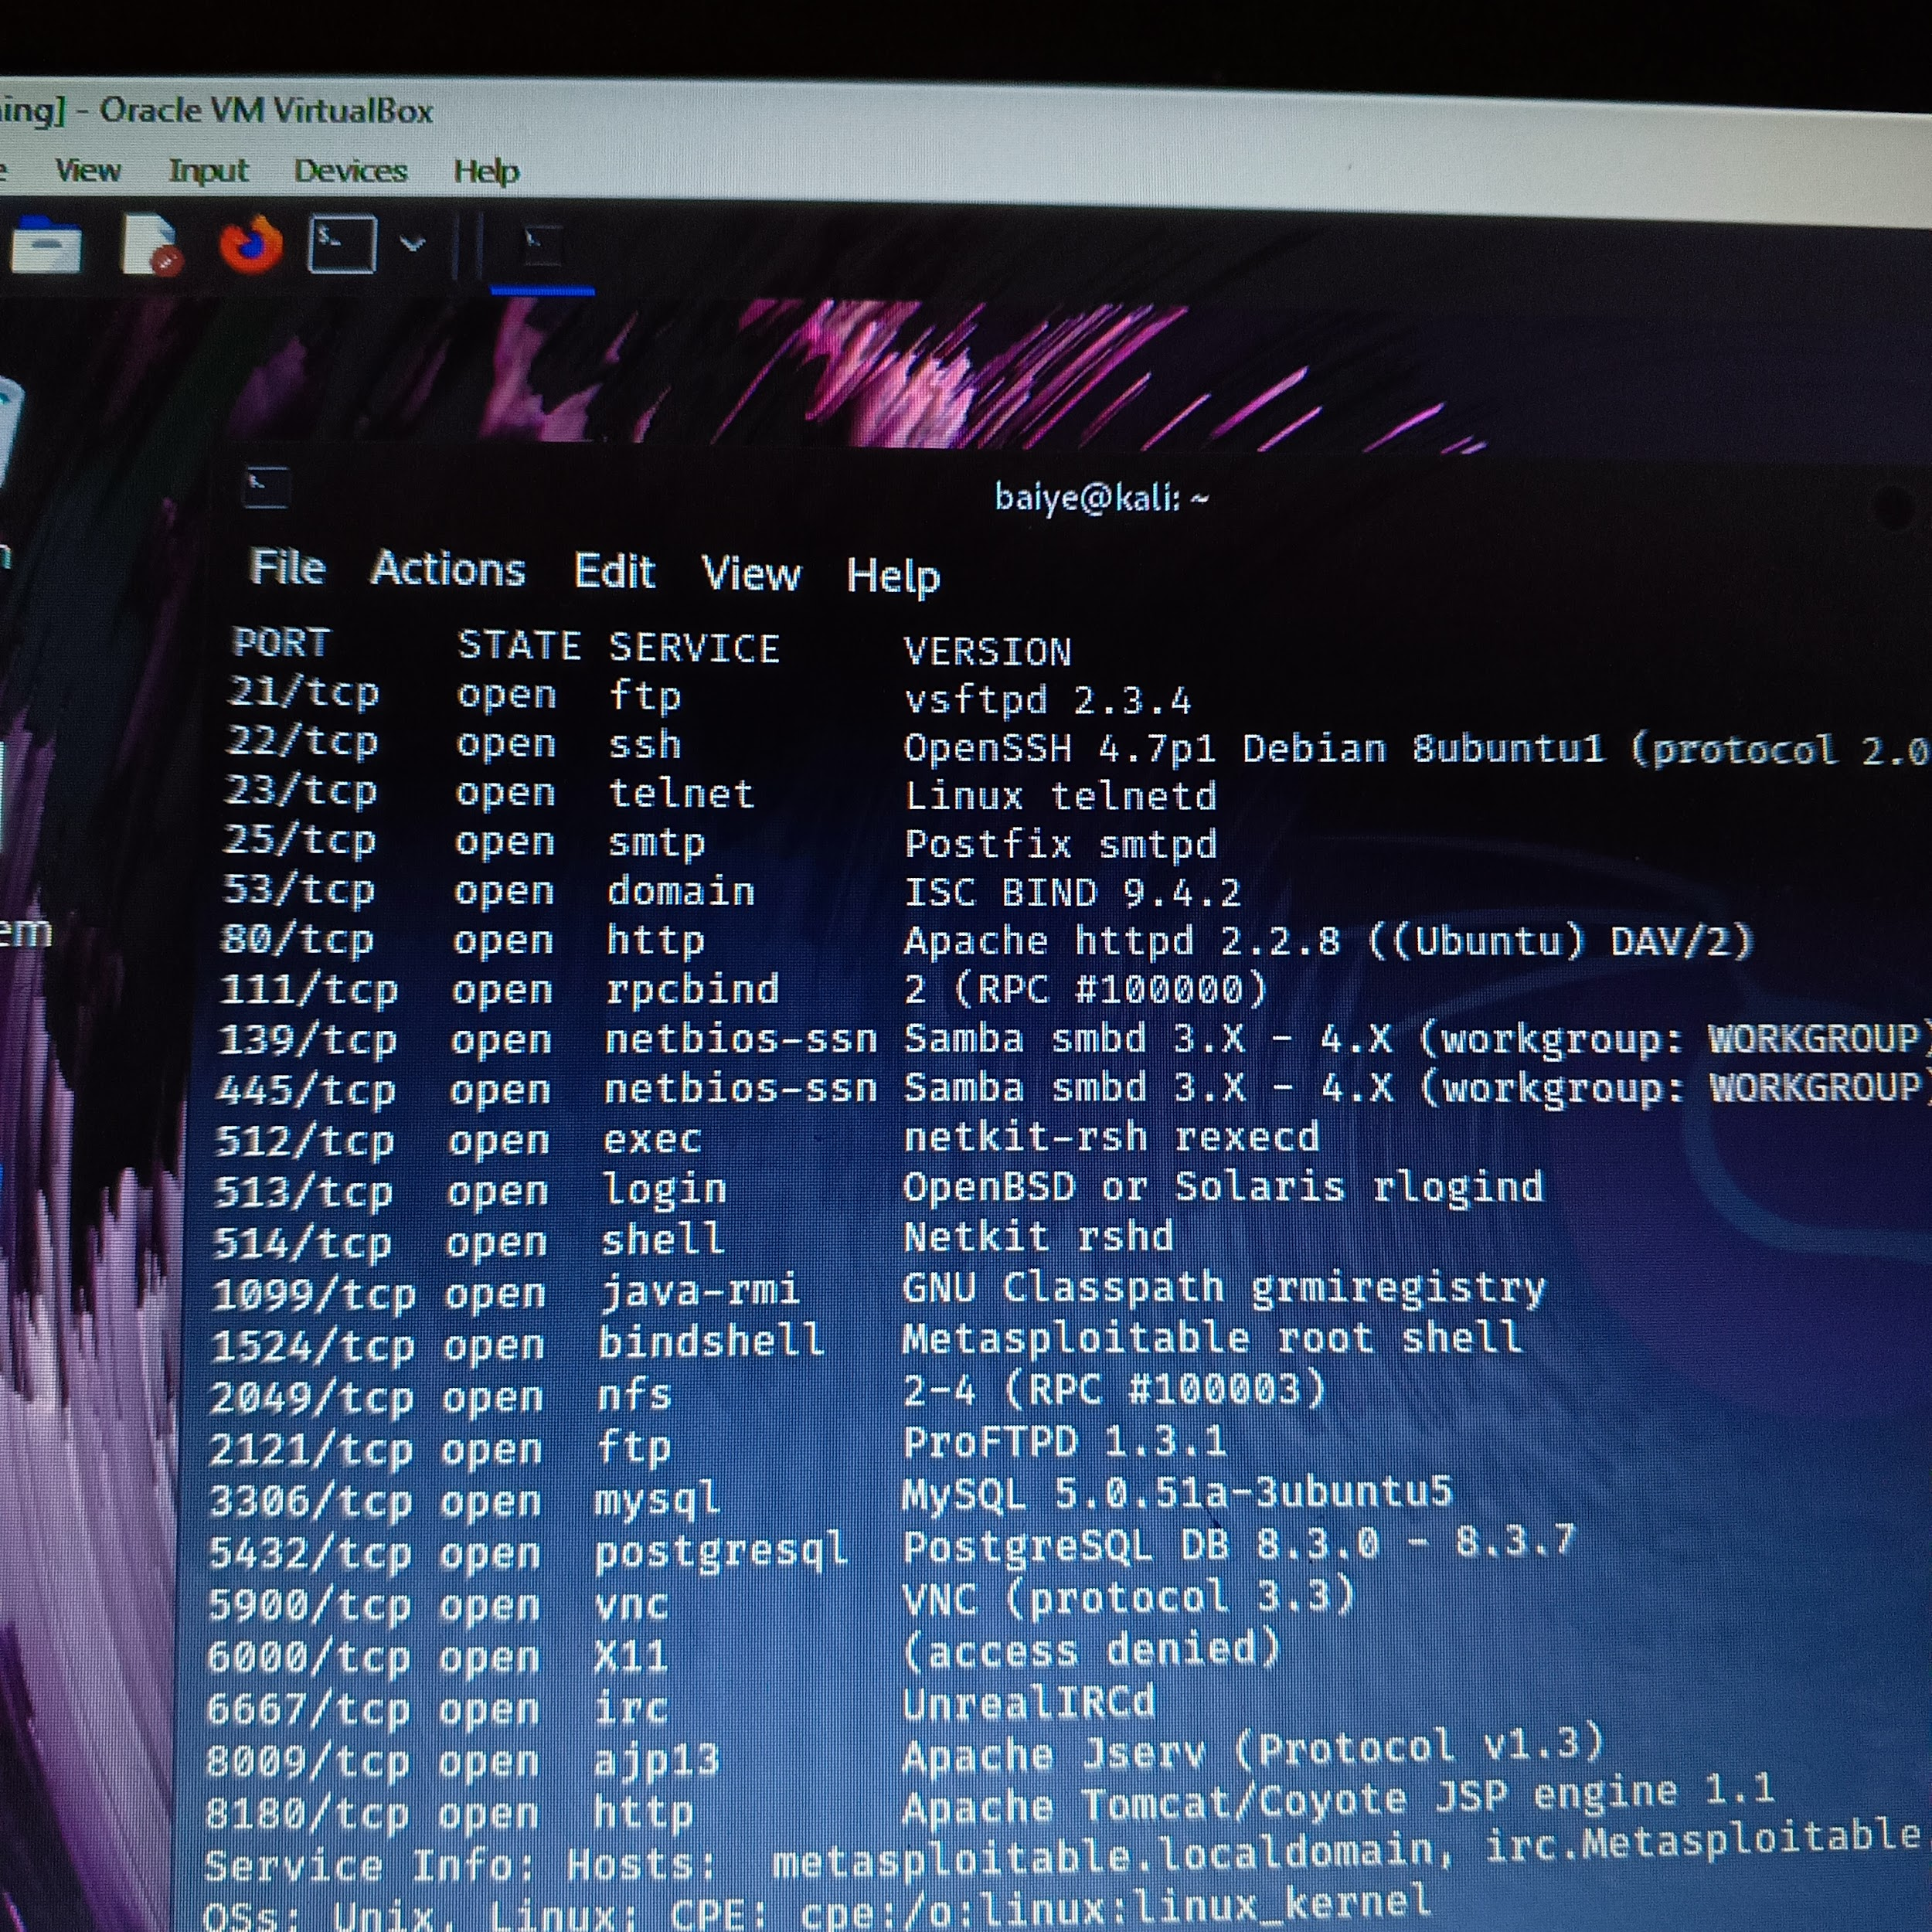

### **🛡️ Vulnerability Assessment**

* Nmap scripts (--script vuln)

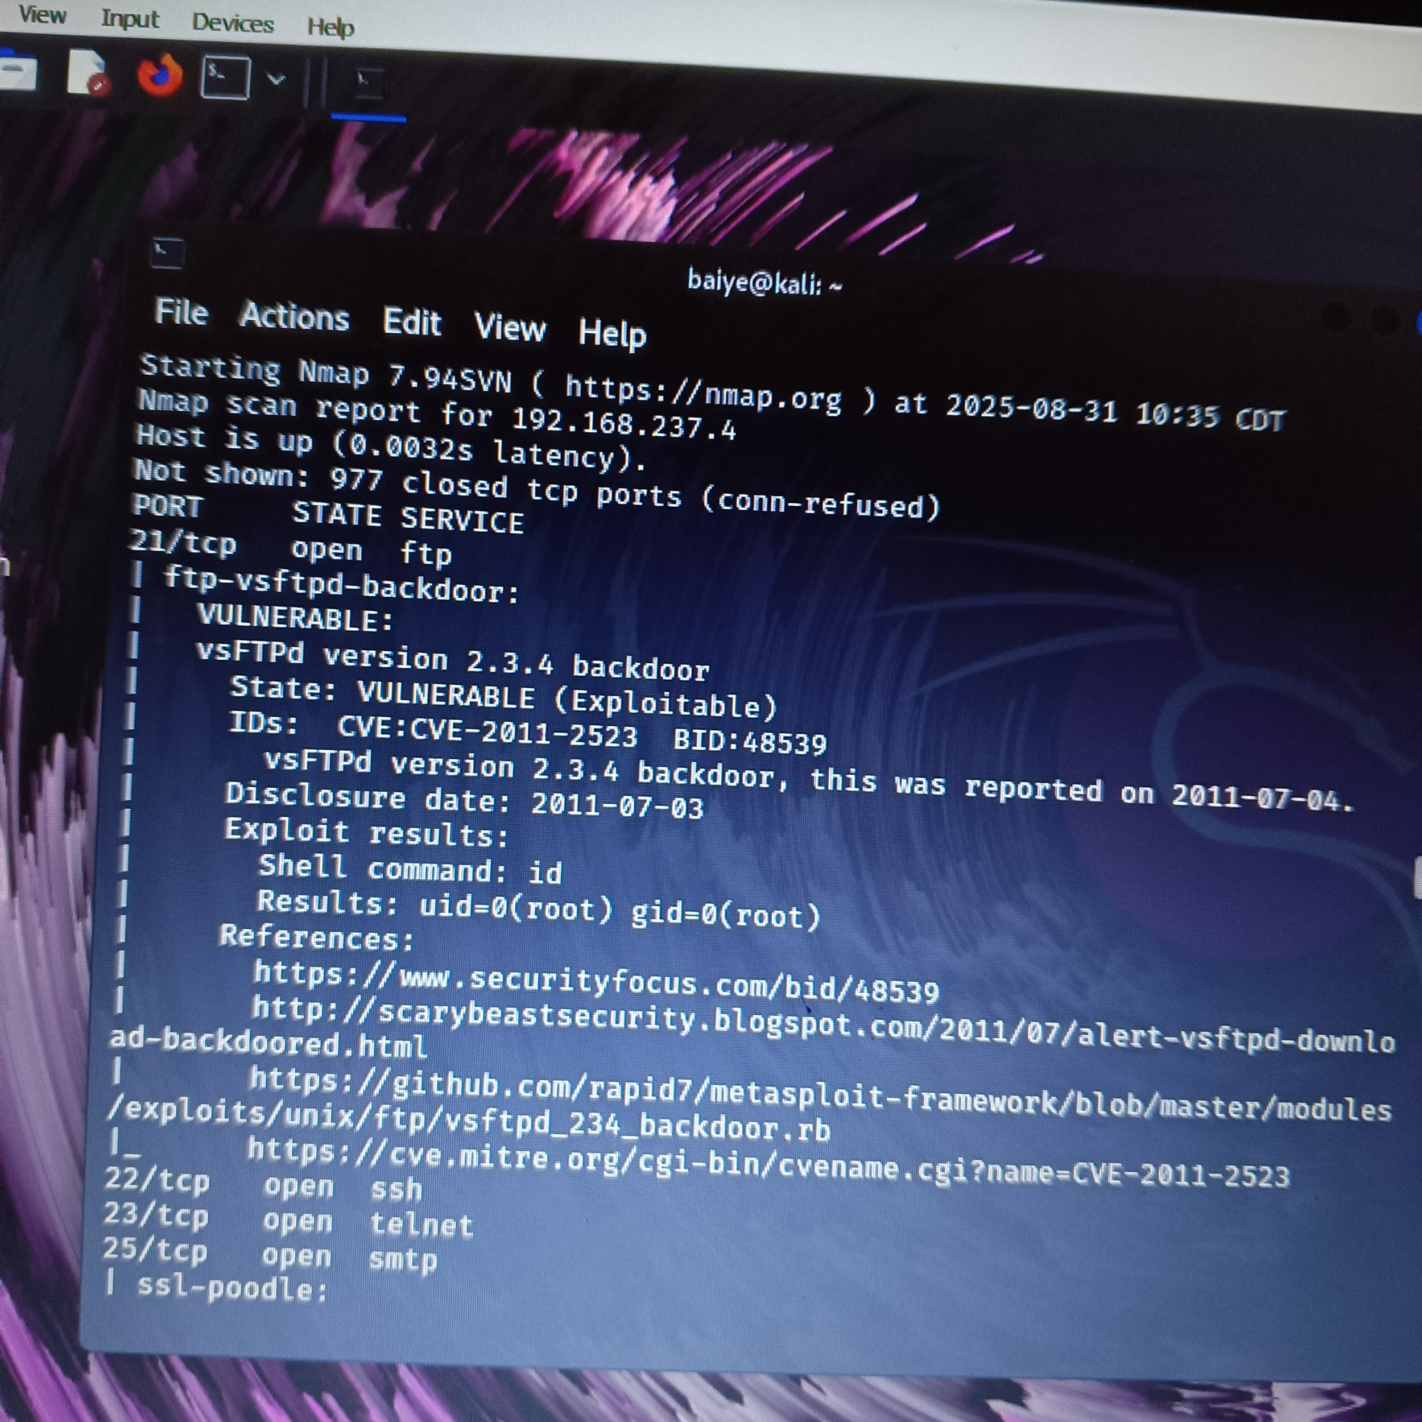

### **💥 Exploitation**

* Metasploit modules (vsftpd_234_backdoor, samba/usermap_script)

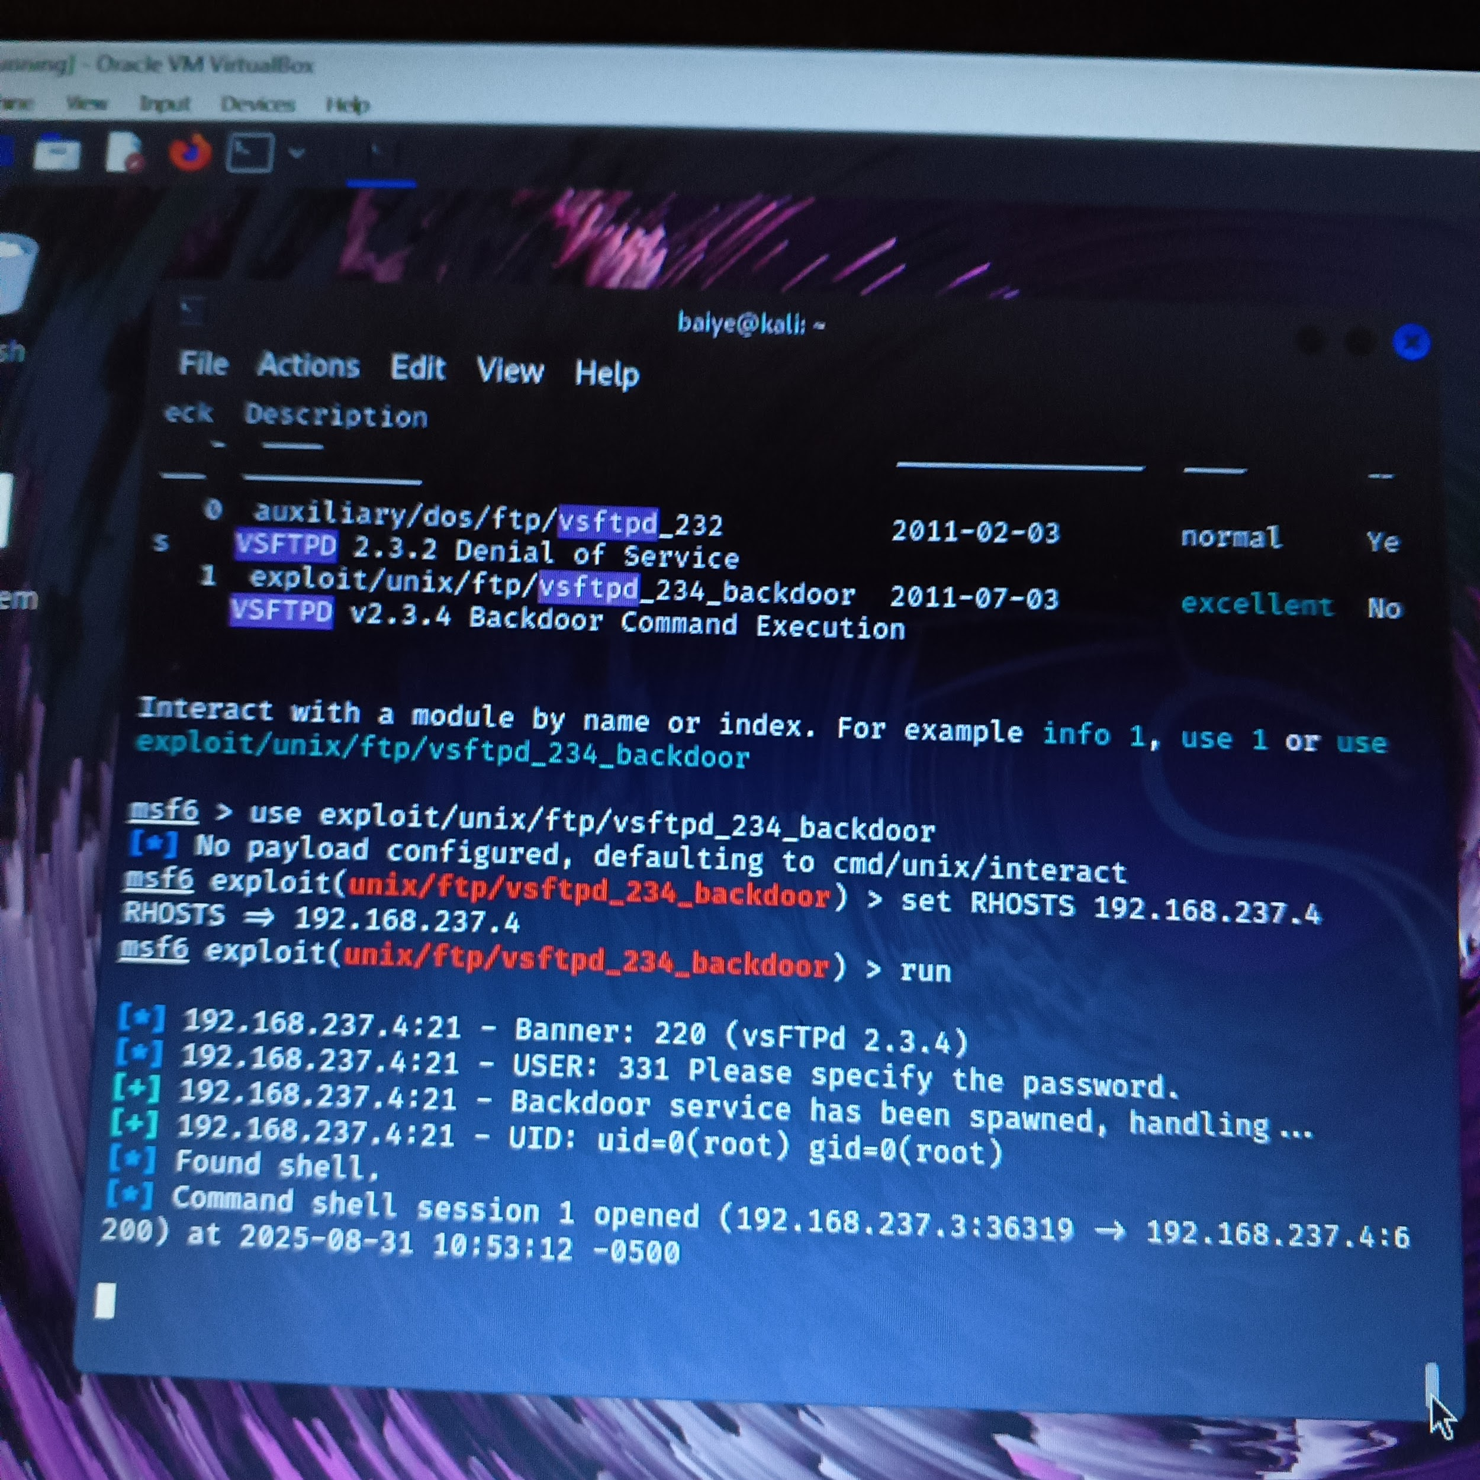

### **🧠 Post-Exploitation**

* Privilege escalation via local_exploit_suggester
* Enumeration of /etc/passwd, /etc/shadow
* Credential dumping with hashdump

### **🌐 Web Application Testing**

* OWASP ZAP scan on Mutillidae and DVWA
* Manual fuzzing for XSS and SQLi

## **3. Findings**

### **🔴 3.1 FTP Backdoor (vsftpd 2.3.4)**

* **CVE**: CVE-2011-2523
* **CVSS**: 10.0 (Critical)
* **Impact**: Remote root shell access
* **Evidence**:
  + Exploit used: exploit/unix/ftp/vsftpd_234_backdoor
  + Shell opened: command shell session 1 opened
  + Screenshot:

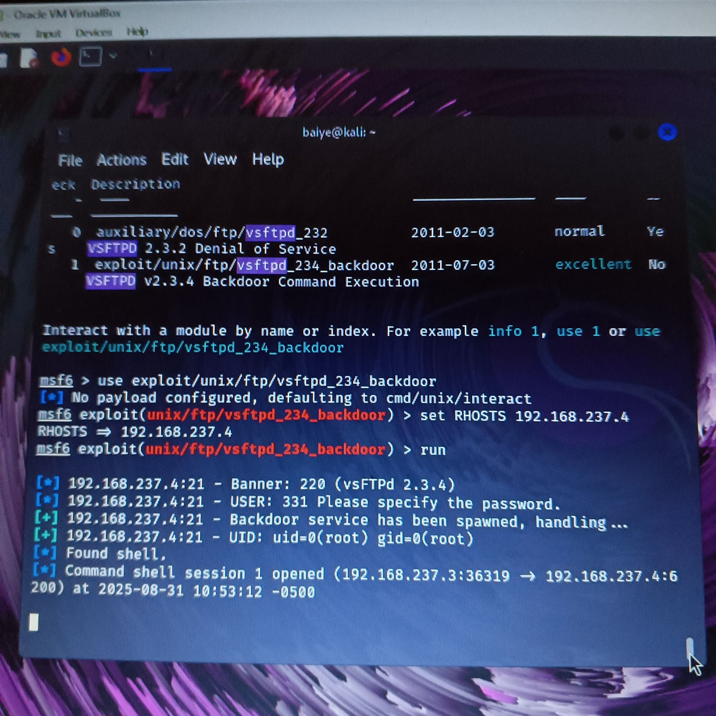

*[Insert your shell screenshot her]*

* **Remediation**: Upgrade vsftpd to a secure version; disable anonymous FTP.

### **🟠 3.2 Samba RCE (Usermap Script)**

* **CVE**: CVE-2007-2447
* **CVSS**: 9.3 (High)
* **Impact**: Remote code execution
* **Evidence**:
  + Exploit used: exploit/multi/samba/usermap_script
  + Shell access confirmed
  + Screenshot: *[Insert shell or Metasploit output]*
* **Remediation**: Patch Samba to latest version; restrict access to port 445.

### **🟡 3.3 SQL Injection in DVWA**

* **CVE**: N/A (Custom app)
* **CVSS**: 7.5 (High)
* **Impact**: Database access, data manipulation
* **Evidence**:
  + Payload: ' OR '1'='1
  + Screenshot: *[Insert DVWA login bypass or data dump]*
* **Remediation**: Use parameterized queries; sanitize user inputs.

### **🟠 3.4 XSS in Mutillidae**

* **CVSS**: 6.1 (Medium)
* **Impact**: Session hijacking, defacement
* **Evidence**:
  + Payload: <script>alert('XSS')</script>
  + Screenshot: *[Insert alert box or ZAP alert]*
* **Remediation**: Encode output; use CSP headers.

### **🟡 3.5 Weak SSH Credentials**

* **CVSS**: 5.0 (Medium)
* **Impact**: Unauthorized access
* **Evidence**:
  + Hydra brute-force: msfadmin:msfadmin
  + Screenshot: *[]*
* **Remediation**: Enforce strong passwords; disable root login.

### **🟢 3.6 Information Disclosure via /etc/passwd**

* **CVSS**: 3.5 (Low)
* **Impact**: User enumeration
* **Evidence**:
  + Output: cat /etc/passwd
  + Screenshot: *[Insert terminal output]*
* **Remediation**: Restrict file access; monitor for enumeration attempts.

**Scope:** The assessment was limited to the single Metasploitable2 virtual machine with the ip address:- 192.168.237.4

## **4. Risk Summary**

| **Vulnerability** | **CVSS Score** | **Severity** | **Status** |
| --- | --- | --- | --- |
| FTP Backdoor | 10.0 | High | Exploited |
| Samba RCE | 9.3 | High | Exploited |
| SQL Injection | 7.5 | High | Confirmed |
| XSS | 6.1 | Medium | Confirmed |
| Weak SSH Credentials | 5.0 | Medium | Exploited |
| Information Disclosure | 3.5 | Low | Confirmed |

## **5. Remediation Recommendations**

| **Issue** | **Recommendation** |
| --- | --- |
| FTP Backdoor | Upgrade vsftpd; disable anonymous access |
| Samba RCE | Patch Samba; restrict port 445 |
| SQL Injection | Use parameterized queries |
| XSS | Sanitize inputs; apply output encoding |
| Weak SSH Credentials | Enforce password complexity; use key-based auth |
| Information Disclosure | Harden file permissions |

## **6. Appendices**

* **Tools Used**: Nmap, Metasploit, OWASP ZAP,
* **Screenshots**:
* **Logs**: *[Include terminal outputs or ZAP alerts]*
* **References**: OWASP Top 10, CVE Details, NIST CVSS Calculator.

## **Lateral Movement (if multi-host lab)**

Scan the internal network:

ip a

nmap -sP 192.168.237.4/24

Use credentials or exploits to pivot to other machines.

Example: Use SSH with stolen credentials:

ssh user@192.168.236.4

There is only one host, therefore there is no lateral movement.

## **🧹 Step 7: Clean Up (Optional)**

If you want to be stealthy:

history -c

rm -rf /tmp/*

## **🧠 Summary**

Create a log like this:

| **Phase** | **Action Taken** | **Result** | **Notes** |
| --- | --- | --- | --- |
| Initial Access | vsftpd exploit | ✅ Success | Shell access granted |
| Privilege Escalation | DISTCC exploit | ✅ Success | Root access achieved |
| Enumeration | /etc/passwd, /etc/shadow | ✅ Success | Found user accounts |
| Credential Dumping | hashdump module | ✅ Success | Password hashes extracted |
| Lateral Movement | Nmap scan from target | ❌ Skipped | No second host in lab setup |

| **Phase** | **Tools Used** | **Goal** |
| --- | --- | --- |
| Reconnaissance | Nmap | Identify open ports/services |
| Exploitation | Metasploit | Gain access to system |
| Post-Exploitation | Meterpreter/Shell | Enumerate system info |
| Privilege Escalation | Kernel exploits | Gain root access |
| Lateral Movement | SSH/Nmap | Access other systems |
| Credential Dumping  Active RECONNAISSANCE with nmap. | John/Mimikatz | Extract and crack credentials |



Nmap script

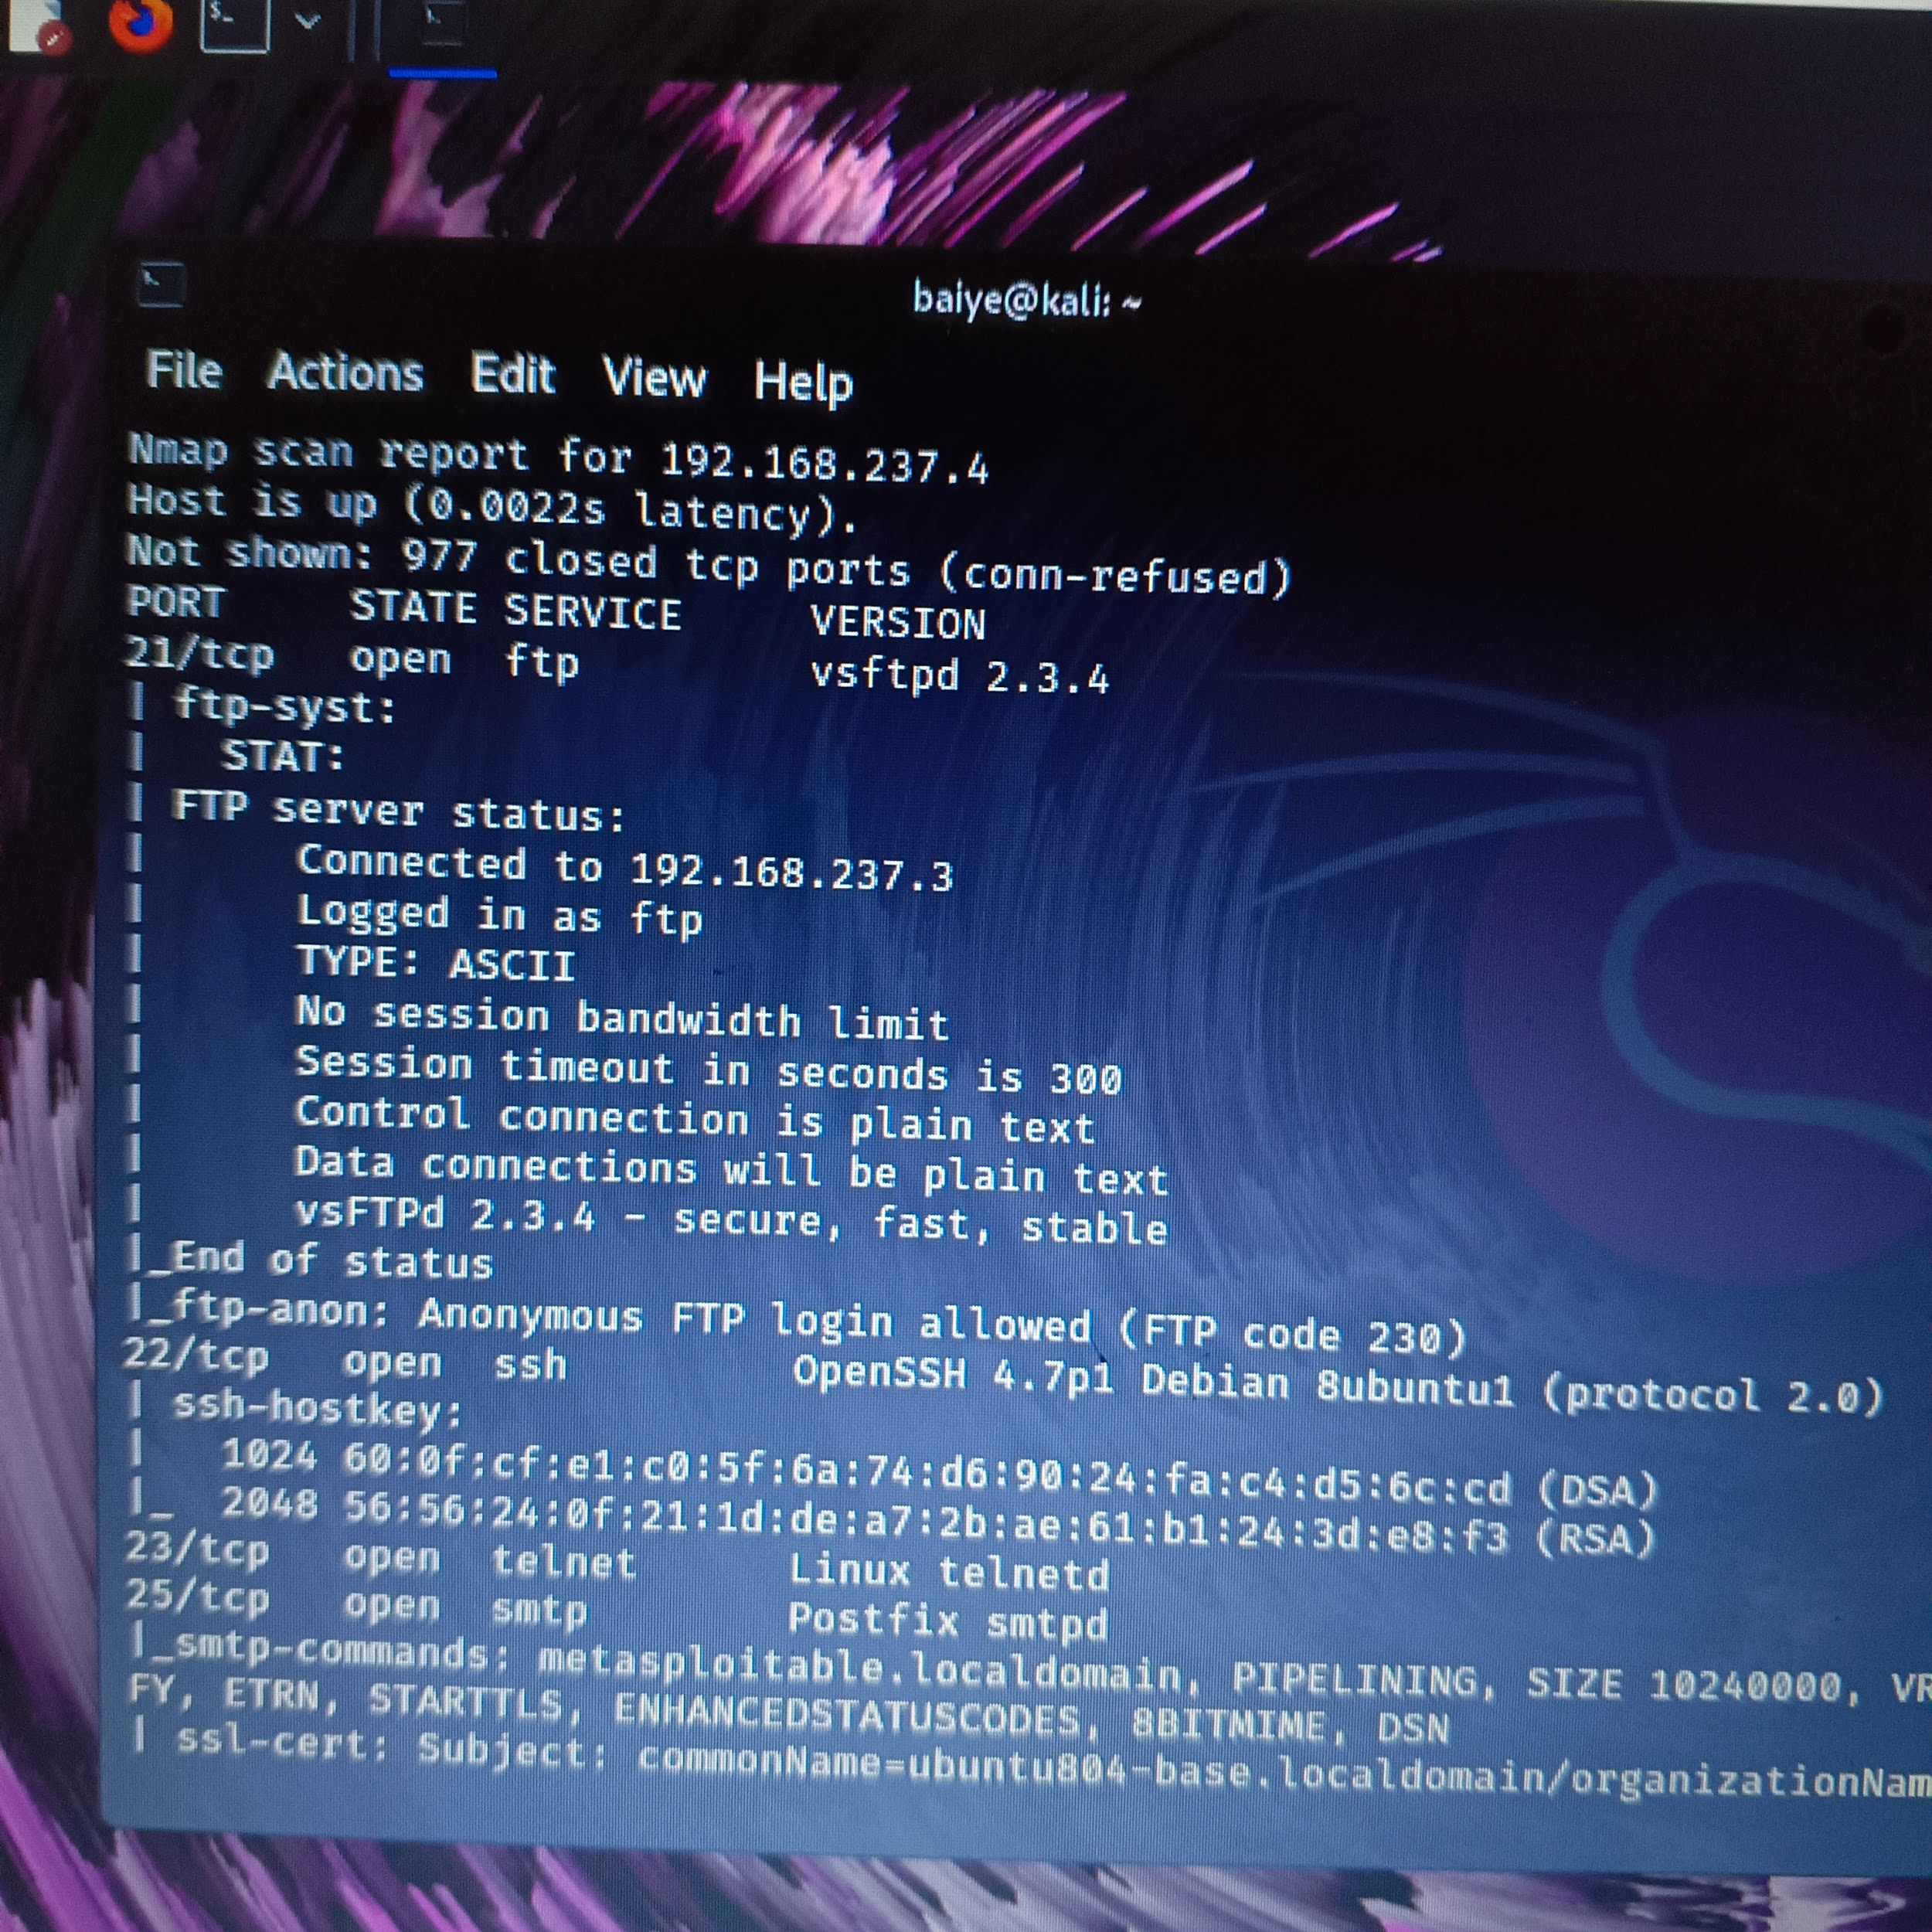

VULNERABILITY ASSESSMENT with nmap



Exploit find from vulnerability assessment

